**Student ID : 00732**

**Name : Aung Min Khant**

**Submission Date** : 15.5.2023

**Higher Diploma in Information Technology**

**(HDIT)**

**British University College**



Table of Contents

Section A 3

1) Project Overview 3

**1.1)** **Purpose** 3

**1.2)** **Scope** 3

**1.3)** **Project Constraints and Risks** 3

**1.4)** **Budget and Schedule Summary** 4

2) Requirements Definition 4

**2.1)** **Software Requirement** 4

**2.2)** **Hardware Requirement** 4

**2.3)**  **Project Members** 4

**2.4)** **Functional Requirement** 5

**2.5)** **Non-Functional Requirements** 5

3) Work Breakdown Structure 5

4) Gantt-Chart 6

5) Budgeting 6

Section B 7

1) UML Diagrams 7

**1.1)** **Use Case Diagram** 7

**2.1)** **ER Diagram** 8

**2.2)** **Sequence Diagram** 9

**2.3)** **Activity Diagram** 10

2) Process Descriptions 10

Section C 12

Database Design 12

**“LuckyDrawDB” database** 12

**Admin table** 12

**Bank table** 12

**User table** 12

**Ticket Category table** 13

**Ticket table** 13

**Purchase table** 14

**Winner** 14

User Interface 14

Security Features of the System 18

Section D: System Testings & Implementations 18

**Test Plan** 18

**Test Data & Result** 19

Changeover Procedure (System Implementation Plan) 28

User Manuals 28

Section E: Critical Appraisal 33

﻿System Limitations 33

Recommended Changes 33

Critical Reflection of the project experience 33

# **Section A**

## **Project Overview**

We'd like to introduce our web application to begin this document named “Prizemania”, where you can participate in the monthly lucky draw program to get valuable prizes with the biggest prize, “iPhone 14 Pro Max”, followed by “iPhone 14 Pro”, “PlayStation 5”, and the finally, “AirPod Pro 2”. The user can buy many tickets to get the higher chance of getting the prizes with a price of 20,000 kyats each. The user must have a bank account to buy tickets. The winner will be chosen by the admin. Then, the user will be phoned when he or she is chosen as a winner. He or She will be also announced in the home page as a winner for the month.

### **Purpose**

Our main purpose is to create a web application for people who are finding to participate an online lucky draw program to get high value demanding electronic devices with an affordable ticket price. The user can easily access to our page with easy registration but he or she will need a bank account to buy tickets.

### **Scope**

We would like to talk about the services we will use in our program as well as the goals of our project.

Project objectives:

1. Login and Signup features: If a user doesn't already have an account, they can log in and create one.
2. Purchase features: Users can buy their tickets to participate in the lucky draw program.
3. Generate winner features: The admin will generate winner tickets and will contact to the winners via phone number.

These are the functionalities and offerings that our web application will have in order to satisfy the needs of the customers.

Additionally, we'll employ the program that's ideal for our project. Estimated project completion time is one month.

### **Project Constraints and Risks**

There will be limitations when we create our program, such as time, money, and resource limitations, as well as technical challenges. Sometimes, we have to maintain the website if the program has met the unexpected error or the users are having difficulties to use the software. Whatever problems we are encountering with, I think we can quickly identify the most effective options.

### **Budget and Schedule Summary**

The project is anticipated to be finished in about a month. I have included a timetable table with anticipated dates in my project offer paper. Firstly, planning of the project would take about 2 days to finish. Requirement analysis will take another 2 to 3 days. The timeline for design implementation and prototyping will take about another 5 days. After design implementation, we can start the deployment of the website which would take about 2 weeks. Then, we will take another 5 days for the testing of the website. Software implementation, and operations and management will take around 1 week to accomplish.

I'll dive into more detail regarding the budget later. In conclusion, we predict that the total cost of project management would range from $6000 to $10000.

We have completed our project overview. Additionally, we will discuss our project with charts, diagrams, and various issues.

## **Requirements Definition**

To fully develop the project, there are a lot of requirements that we need to research and compile. I'll include the detailed lists of needs for the project in this document.

### **2.1) Software Requirement**

To create the program, we need the right programs and software. We will use the "Visual Studio Code" program to create this project because it is the best for creating web apps using HTML, CSS, JavaScript, PHP, and finally we use “Bootstrap: the front-end framework” for styling the website. We also use MySQL database for storing data and managing data.

### **2.2) Hardware Requirement**

Basic gear needed for the program, such as a computer or a laptop that could run the OS.

### **2.3) Project Members**

|  |  |  |
| --- | --- | --- |
| Roles | Responsibilities | Members Total Needed |
| Client | Client can visit the website and buy tickets to participate in the lucky draw program. | - |
| Stakeholder | Approve the project deliverables. Identify and address any risks or issues connected to the project or program. | More than one stakeholder |
| Project Manager | Verify that each process is functioning properly. Organize the project team as a whole.  Additionally ensure the booked time will be done in time. | At least one PM |
| Analyst | Investigate the project's prerequisites. | Need two or more analysts |
| Developer | Create the features and software. Check to see that the quality of the service meets the needs of the customers. | Need at least 3 or 4 developers |
| Tester | Testing the product regardless of whether it is prepared to send off. | At least 2 testers |

### **2.4) Functional Requirement**

An explanation of the service which the program must provide is a functional requirement. The functional requirement of the program is that user have to register to log into the lucky draw program. For another, users have to buy tickets to participate in the program. The random generate system is added for choosing the winners.

### **2.5) Non-Functional Requirements**

Non-functional requirements relate to qualities like as dependability, efficiency, usability, maintenance, and portability rather than functionality. For the non-functionality of the program is that user can do login and registration in just about 2 or 3 minutes. Users can also buy tickets in less than a minute. Those make the users save a lot of time. The program is also made for the users to be user friendly so that the users can use the website easily.

## **3) Work Breakdown Structure**

Prepared By: Aung Min Khant Date:15.5.2023

Project Name: “PrizeMania”

1.0. Project Initiation

1.1. Assign Project Manager

1.2. Hold a meeting

1.2.1. Assign Project Management Team

1.3. Develop and understand business case

2.0. Project Planning

2.1. Purpose of the Project

2.2. Scope Statement

2.3. Project Members

2.4. Project Timeline

2.5. Schedule and Budget Statement

3.0. Project Developing

3.1. Requirement Analysis

3.2. Design Implementation

3.3. Software Development

3.4. Software Testing

3.5. Operations and Management

3.5.1. Staff Training

3.5.2. Project Launch

4.0. Closeout

## **4) Gantt-Chart**

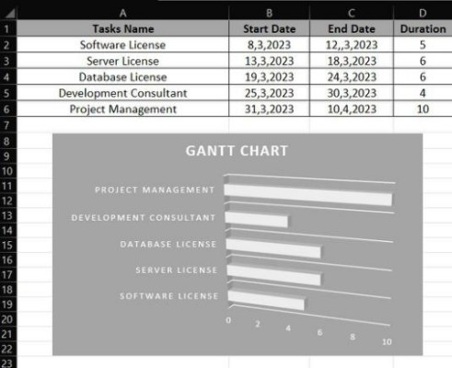

## **5) Budgeting**

|  |  |
| --- | --- |
| Name | Approximate Price |
| Software License | $300 |
| Server License | Between $1000 and $3000 |
| Database License | About $2000 |
| Development Consultant | About $3000 |
| Project Management | Between $6000 and $10000 |

# **Section B**

## **UML Diagrams**

### **Use Case Diagram**

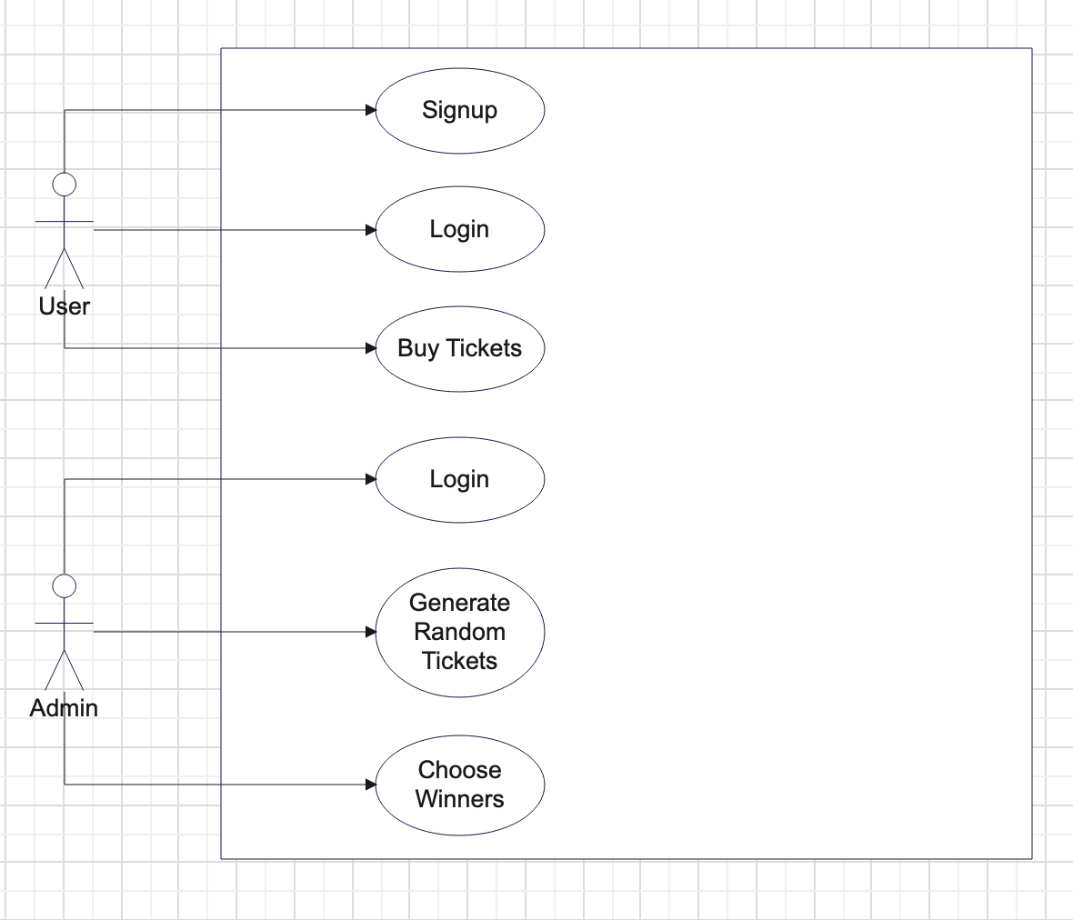

### **2.1) ER Diagram**

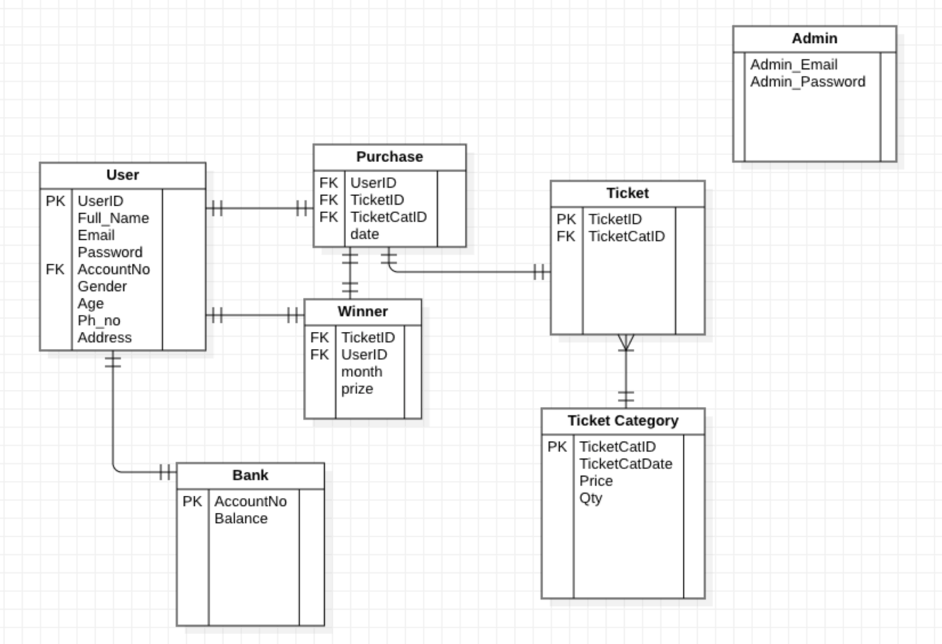

### **2.2) Sequence Diagram**

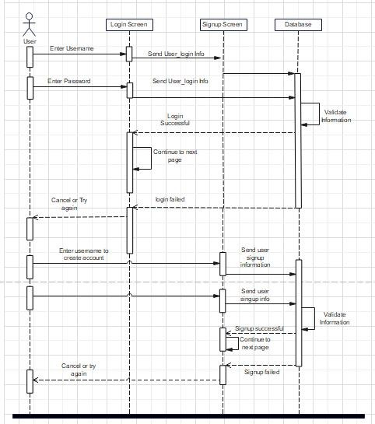

### **2.3) Activity Diagram**

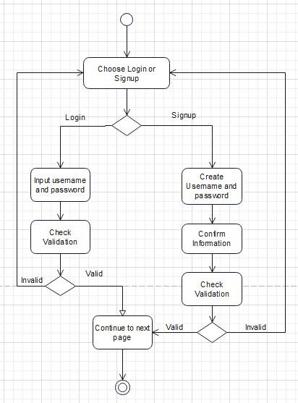

## **Process Descriptions**

In this topic, I will describe the processes in Work breakdown Structure in detail.

|  |  |
| --- | --- |
| **Process Name** | **Description** |
| 1. Project Initiation | - At this stage of the project, every team member has a specific assignment. |
| * 1. Assign Project Manager | - choosing the project manager, who will be in charge of managing the crew and ensuring the project is completed flawlessly. |
| * 1. Hold a Meeting | - The entire project team, including the project supervisor, would come together and talk about the project during this phase. The title of the project and development path will be decided by the members. |
| * + 1. Assign Project Management Team | - The project manager will divide the team into separate groups during the meeting and assign duties to each group. For instance, service, or maintenance, and development teams might exist. |
| * 1. Developing Business Case | - During the meeting, the project manager is going to split the team into distinct groups and assign each group a unique set of tasks to do. The software engineering team, the maintenance squad, the service team, etc. are some examples. |
| 2.0. Project Planning | - The project manager and a select group of the team will establish the crucial project planning phases during this process. |
| 2.1. Project Planning Steps | - Steps in project planning include:  (i) Describe the project's objectives and motivations in order to clarify its meaning.  (ii) In the scope statement, specify the project's outputs and its intended use.  (iii) Schedule and participants in the project: List the profiles of the team players and a schedule synopsis.  (iv) The project's timing and financial details are summarized in the cost and schedule section. |
| 3.0. Project Developing | Once this project has been properly planned, the team responsible for its development will start working on it. |
| 3.1. Requirement Analysis | The analysts will do requirements study prior to beginning the project or program design. |
| 3.2. Design Implementations | The architecture of the web page and the database will be created by developers. |
| 3.3. Software Developments | The appropriate coding and procedures will be used to construct the app. |
| 3.4. Software Testing | Process that is necessary to utilize and must be employed. Regardless of whether the program is ready for launch or not, they will check it and run it. |
| 3.5. Operation and Management | Following adequate software training for the staff, the product will eventually be made accessible to the public as a whole. |

# **Section C**

## **Database Design**

### **“LuckyDrawDB” database**

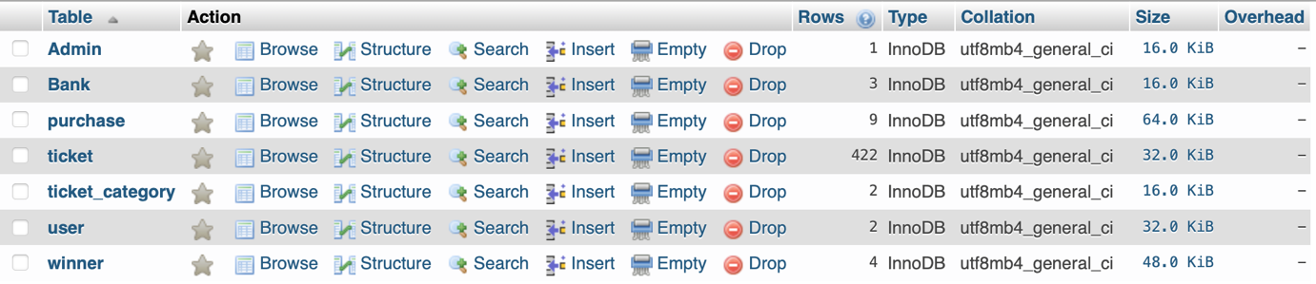

### **Admin table**

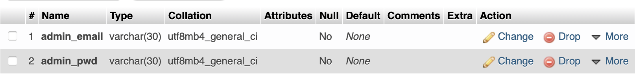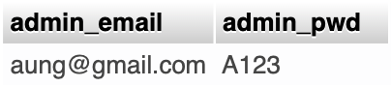

### **Bank table**

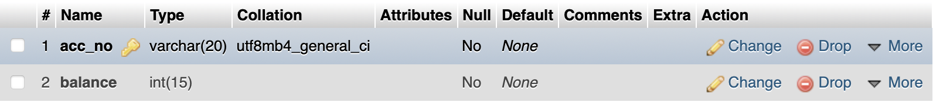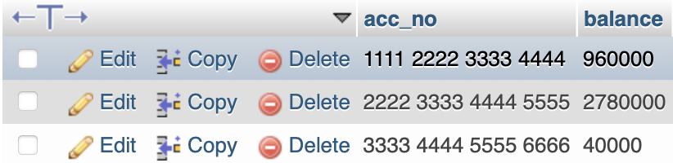

### **User table**

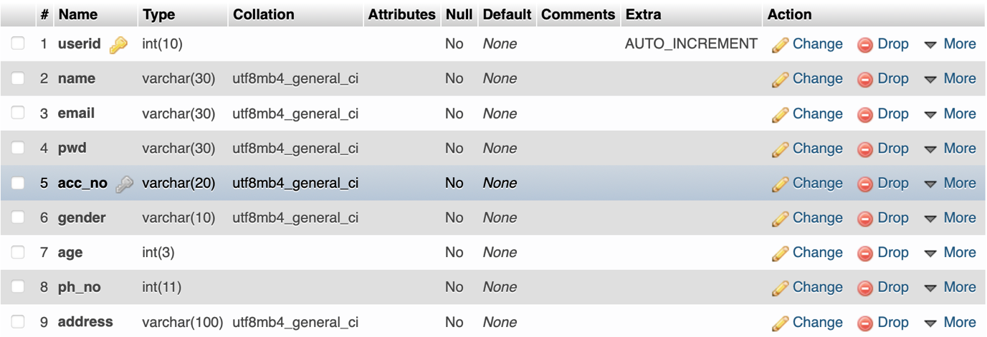

### **Ticket Category table**

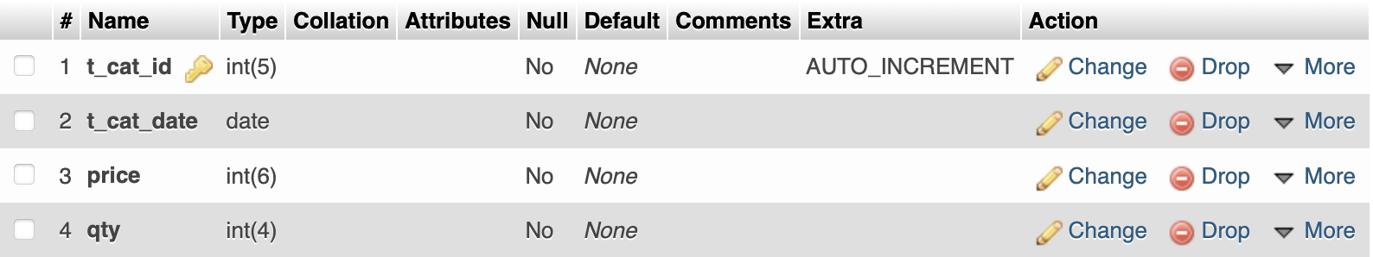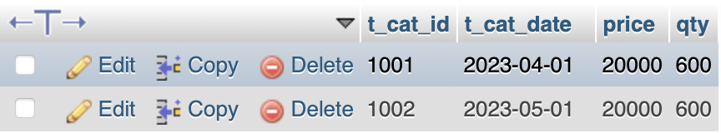

### **Ticket table**

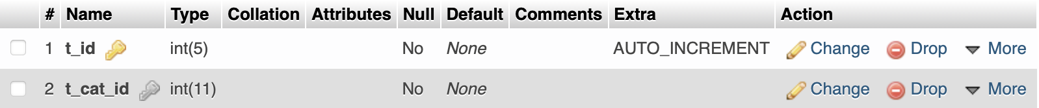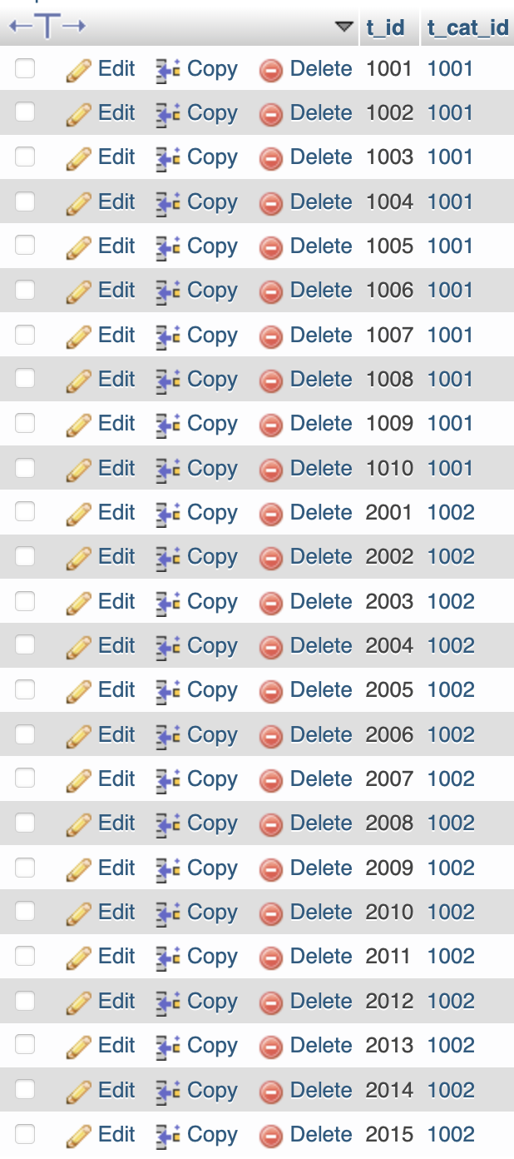

### **Purchase table**

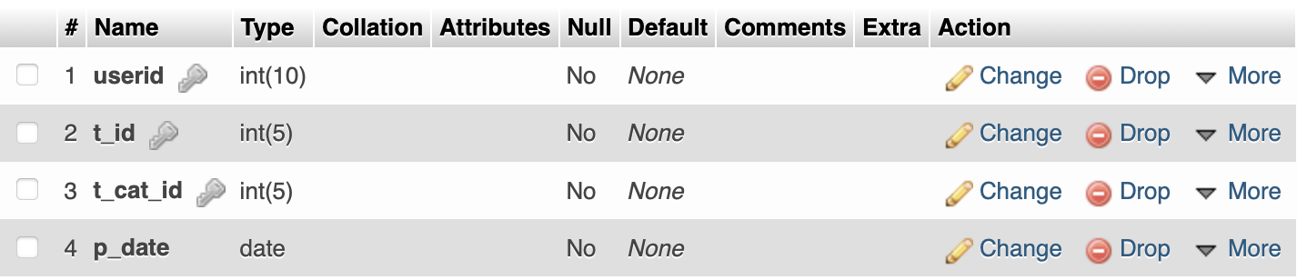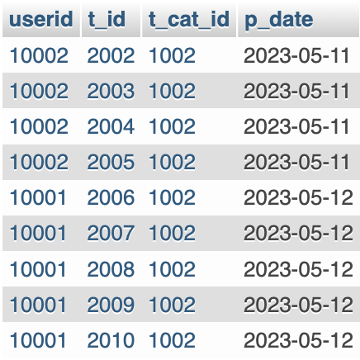

### **Winner**

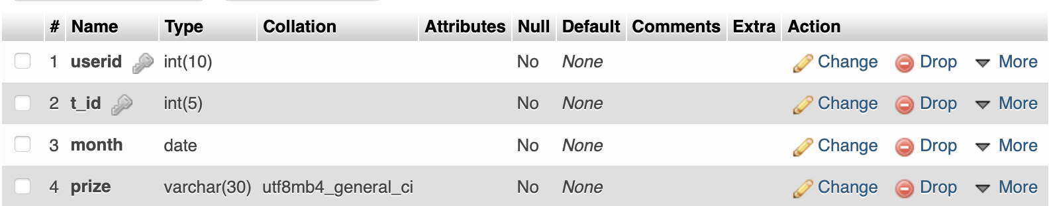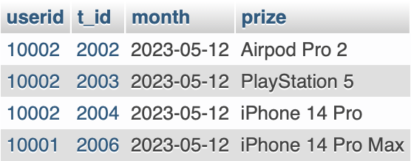

## **Hierarchy Chart**

Home Page

Admin Login Page

User Login Page

Registration Page

Contact Page

About Page

Admin Control Page

Ticket Purchase Page

## **User Interface**

Home Page

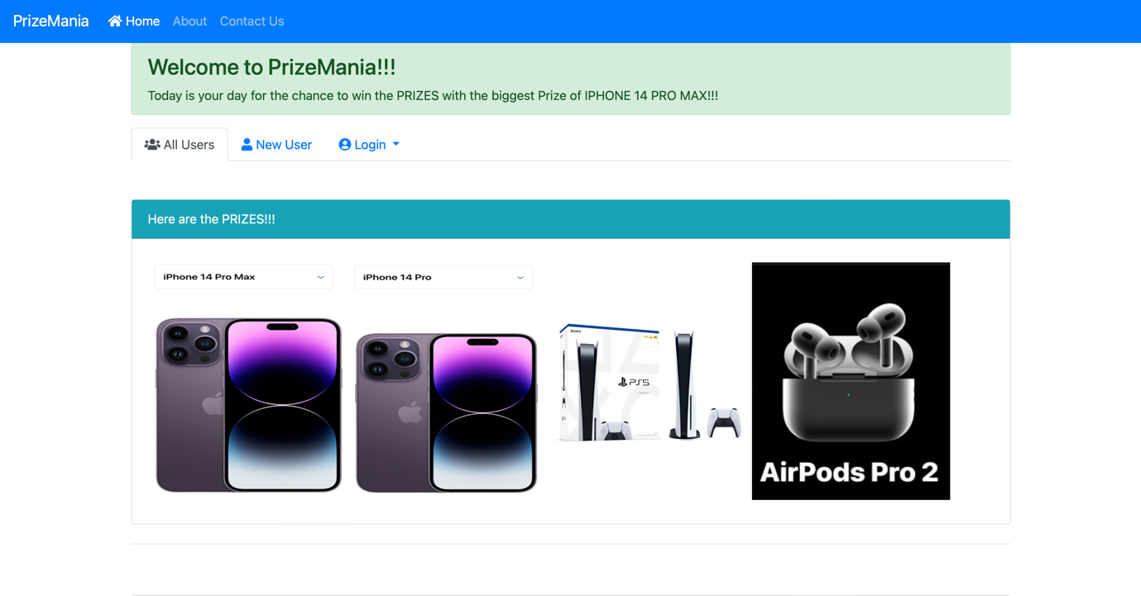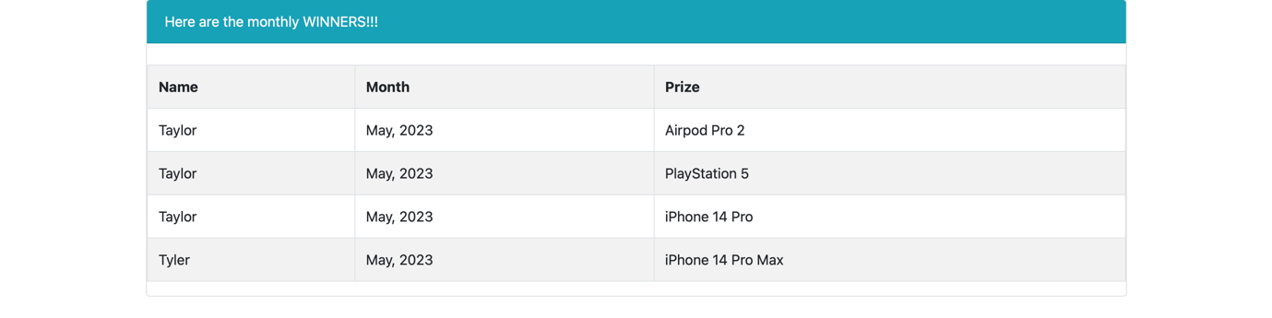

About Page

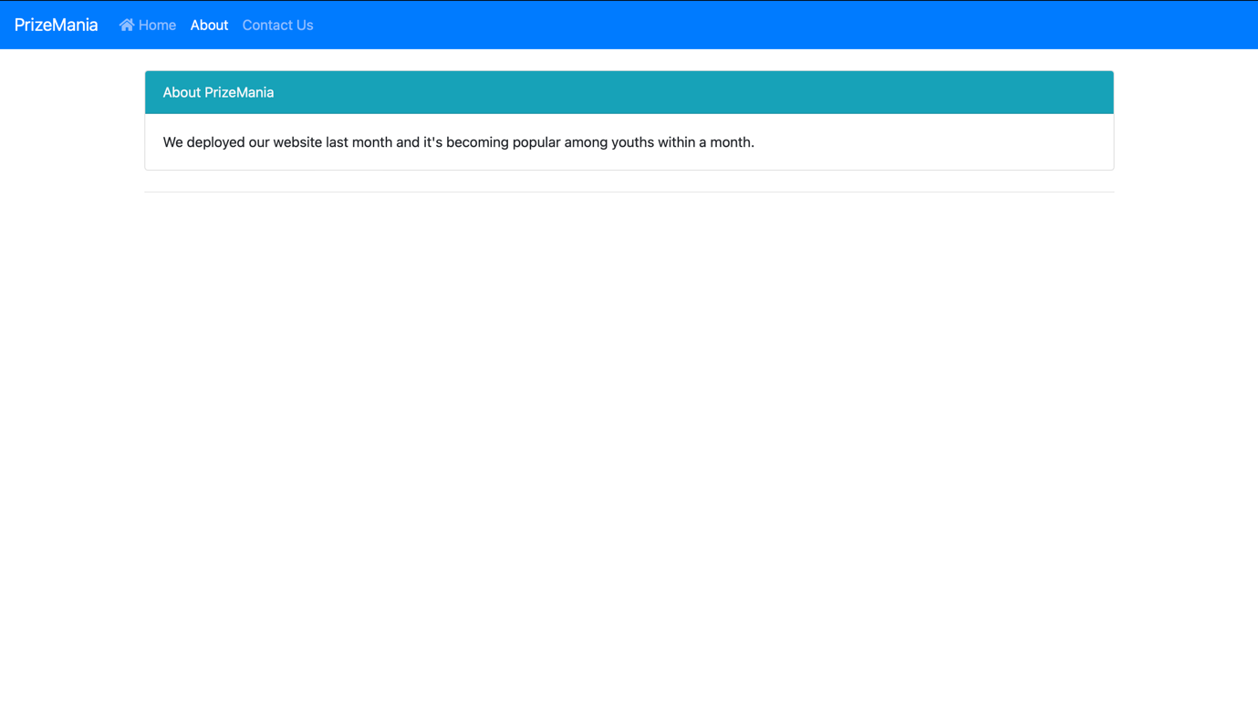

Contact Page

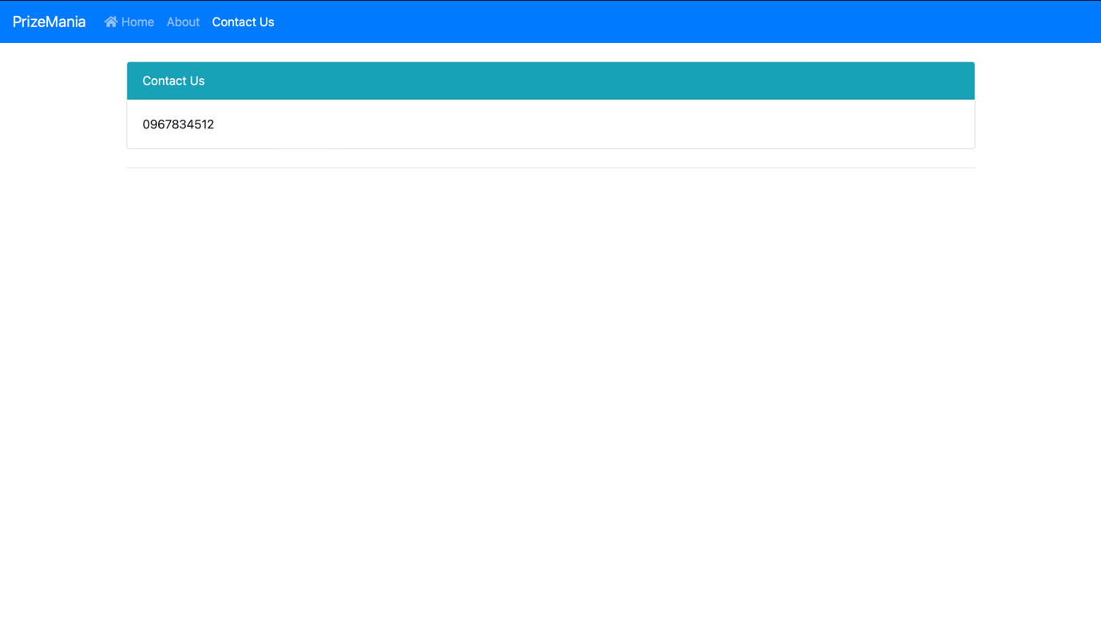

Signup Page

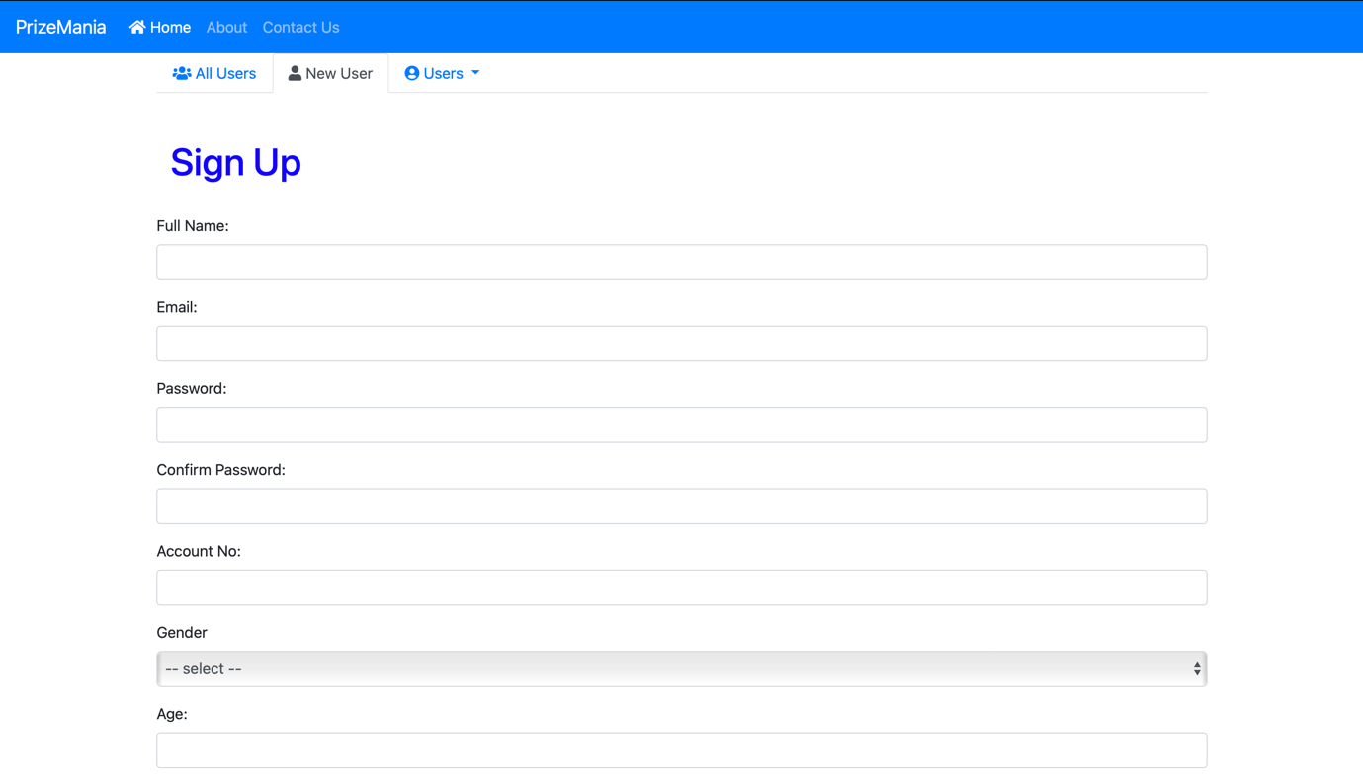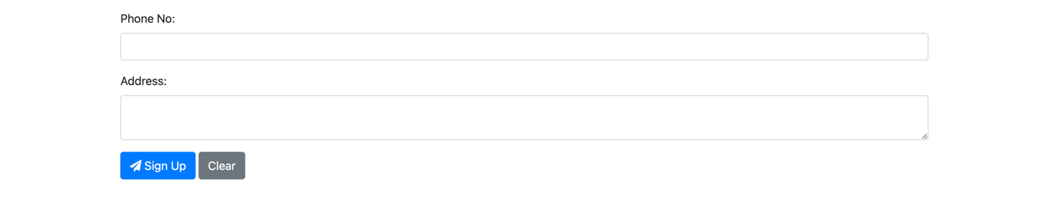

User Login

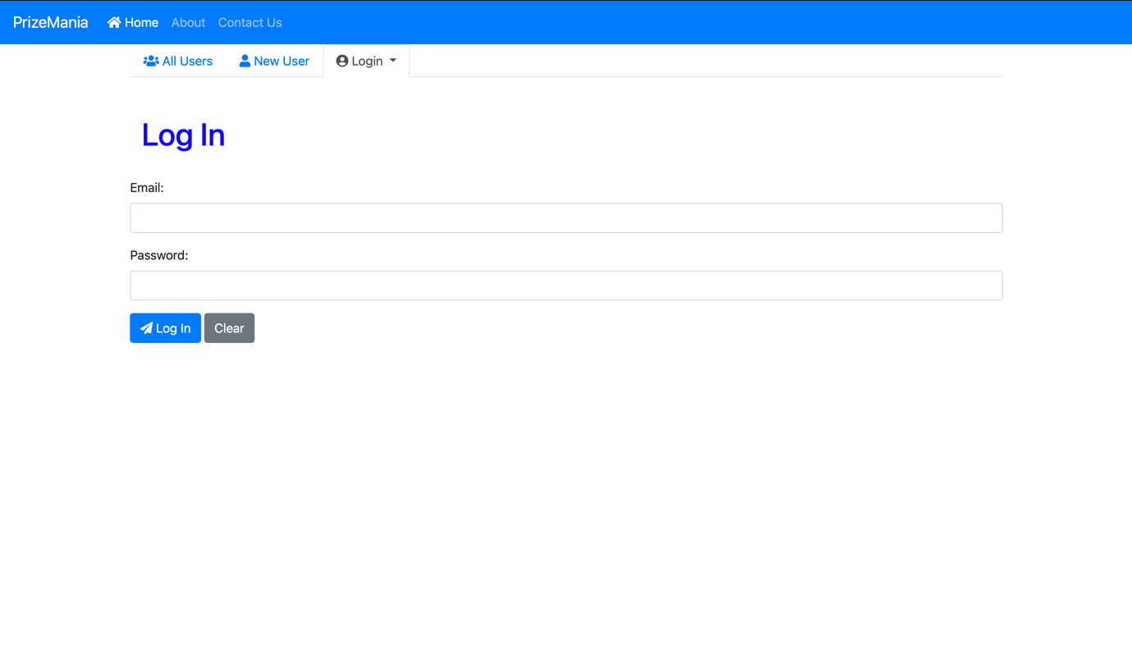

Amin Login

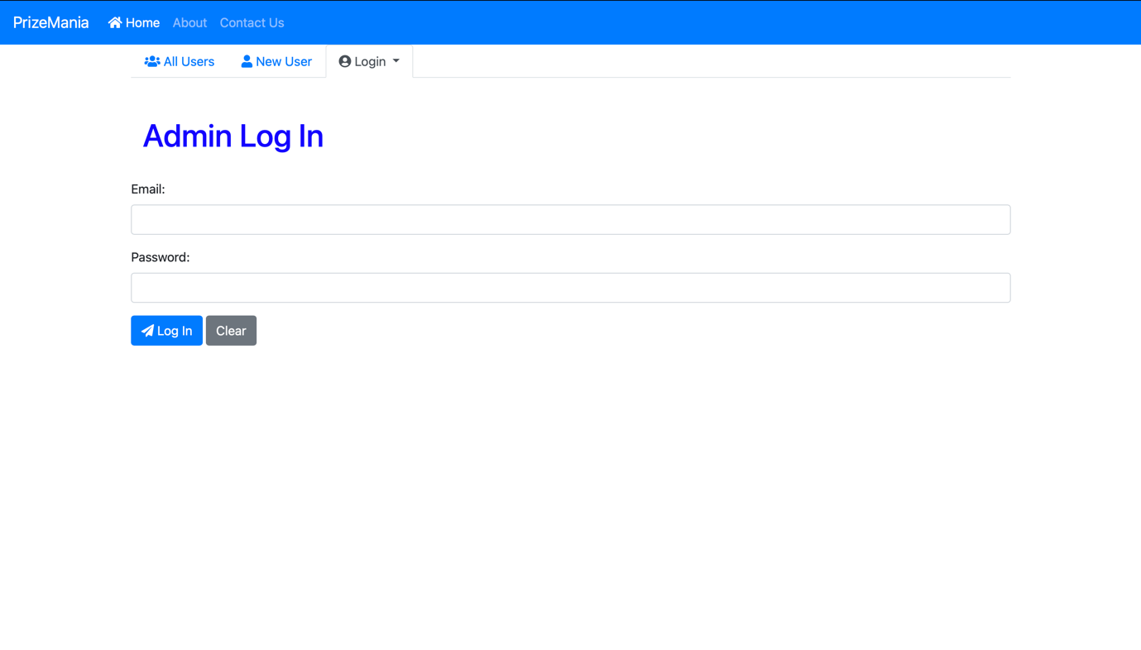

Purchase Ticket Page

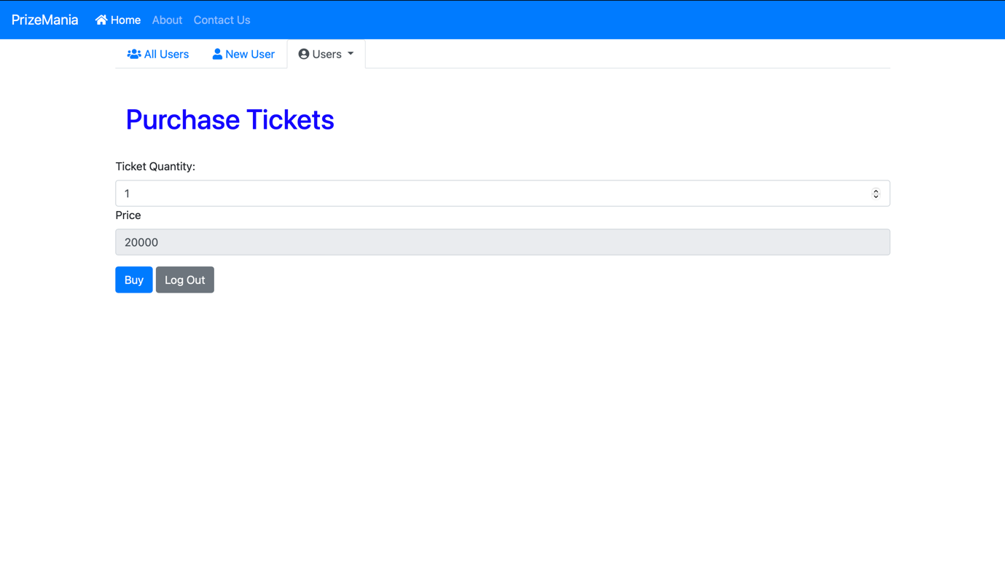

Admin Control Page

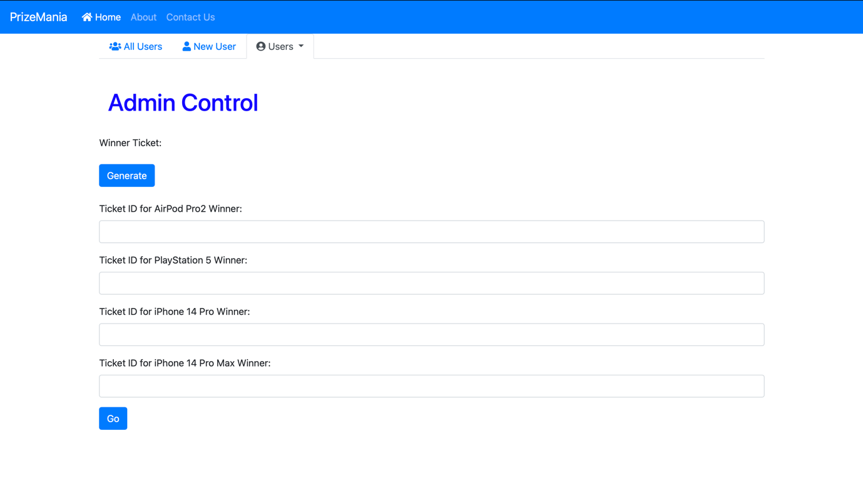

## **Security Features of the System**

Currently, we did not do anything about security within the system, but we will implement soon for the better security.

# **Section D: System Testings & Implementations**

### **Test Plan**

- to verify whether the administrator's user-name and password are properly written.

- to verify that the user filled out all necessary fields

-to test bank account number correctly written or not

-to test purchasing ticket properly doing well

-to test choosing winner work well or not

### **Test Data & Result**

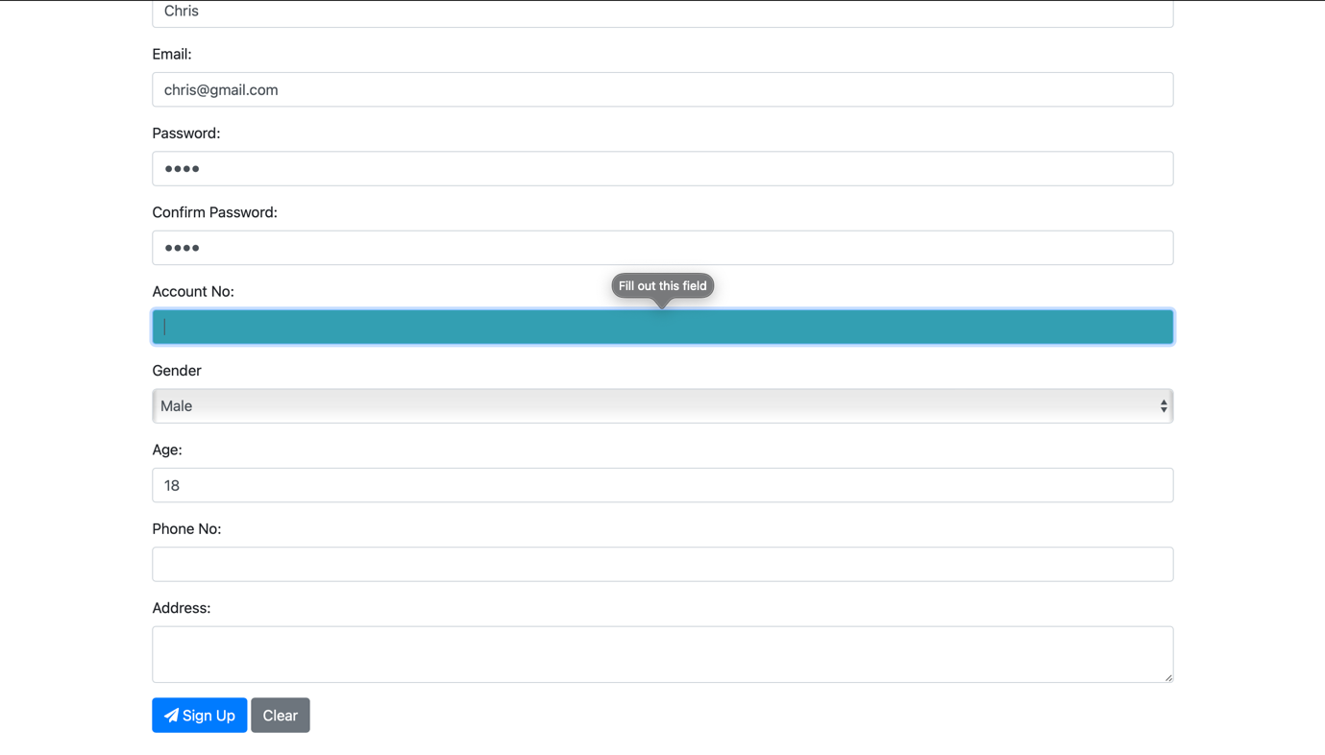

If we do not fill the require field, the signup page does not work.

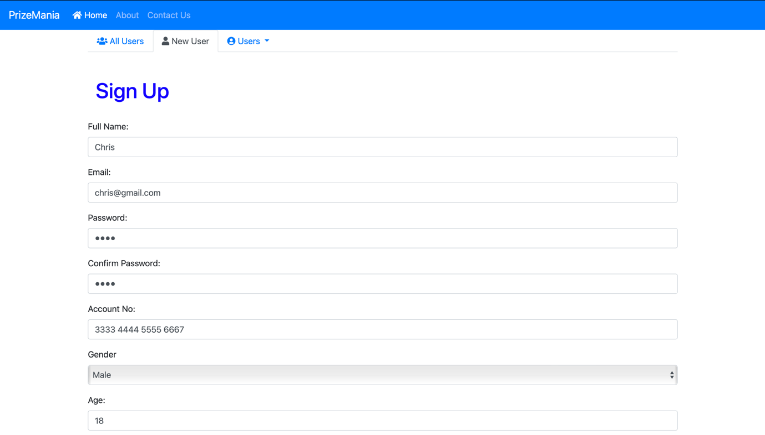

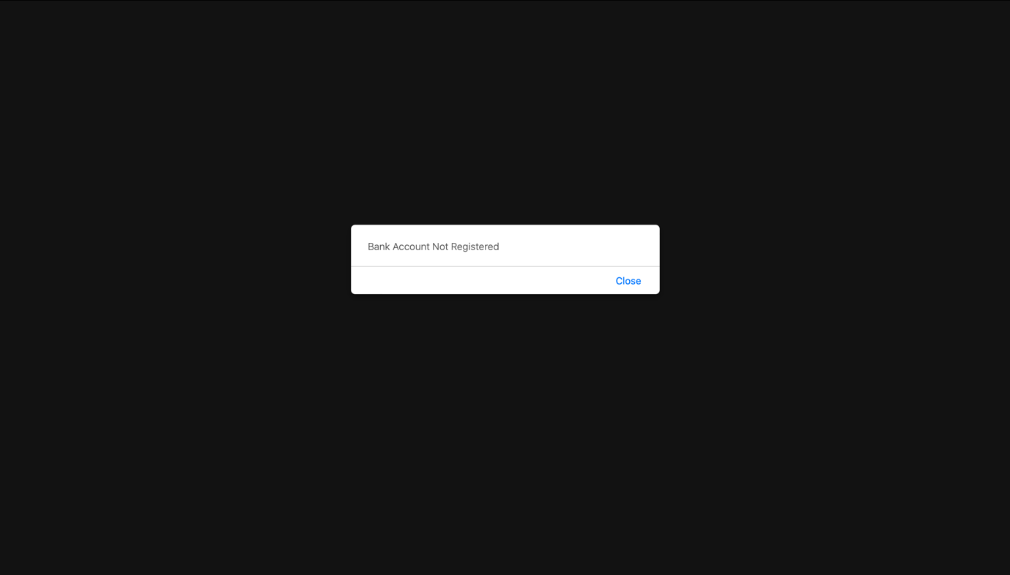

If we write the not existing bank account in the input field, it will show “Bank Account Not Registered”.

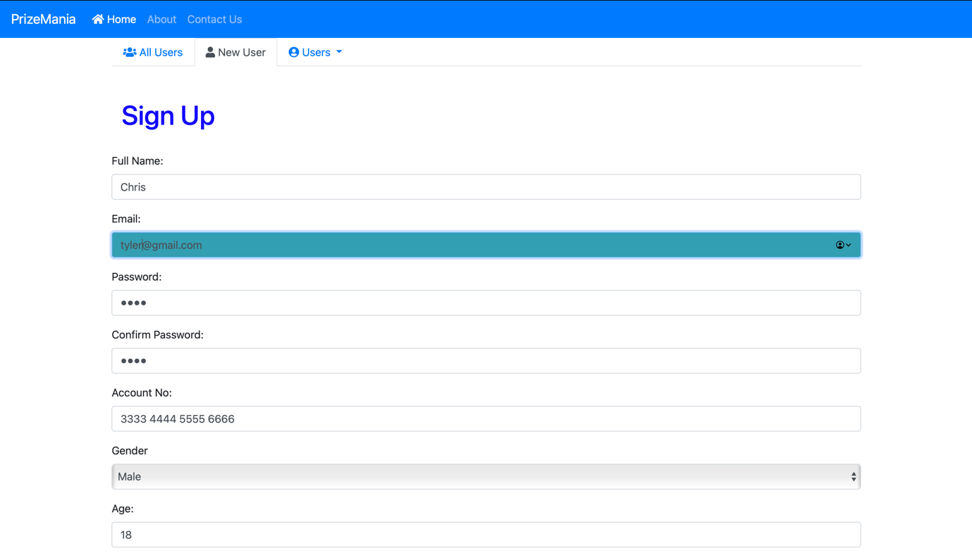

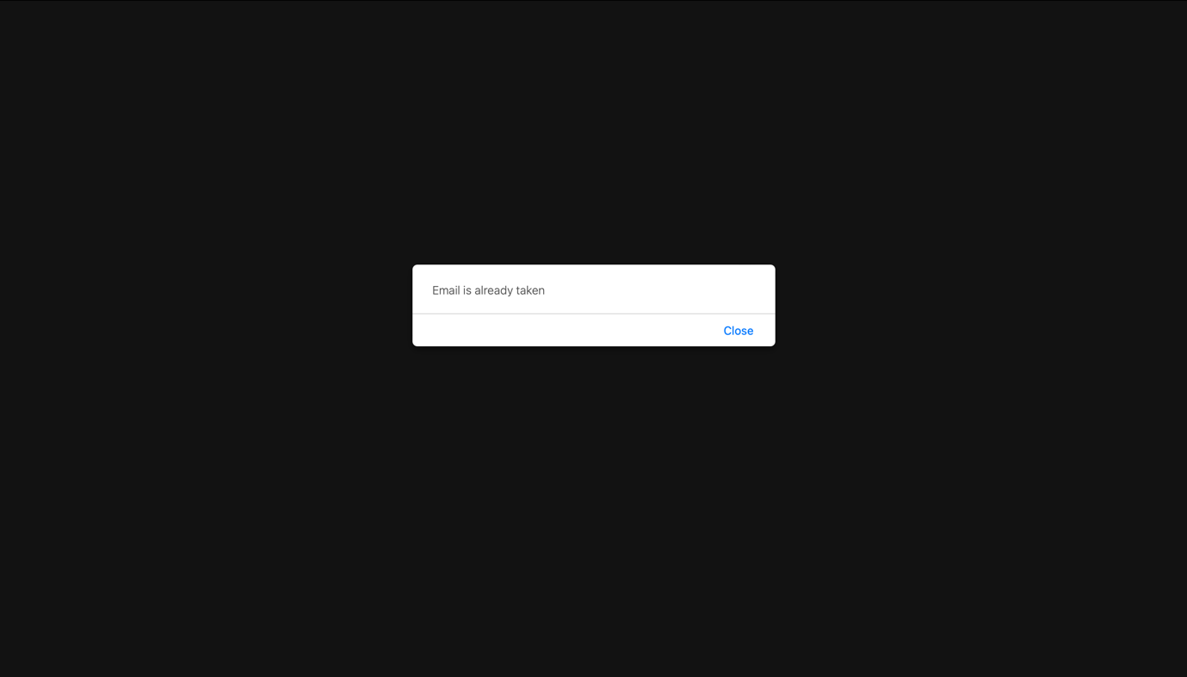

If we write the already taken email address in the input field, it will show “Email is already taken”.

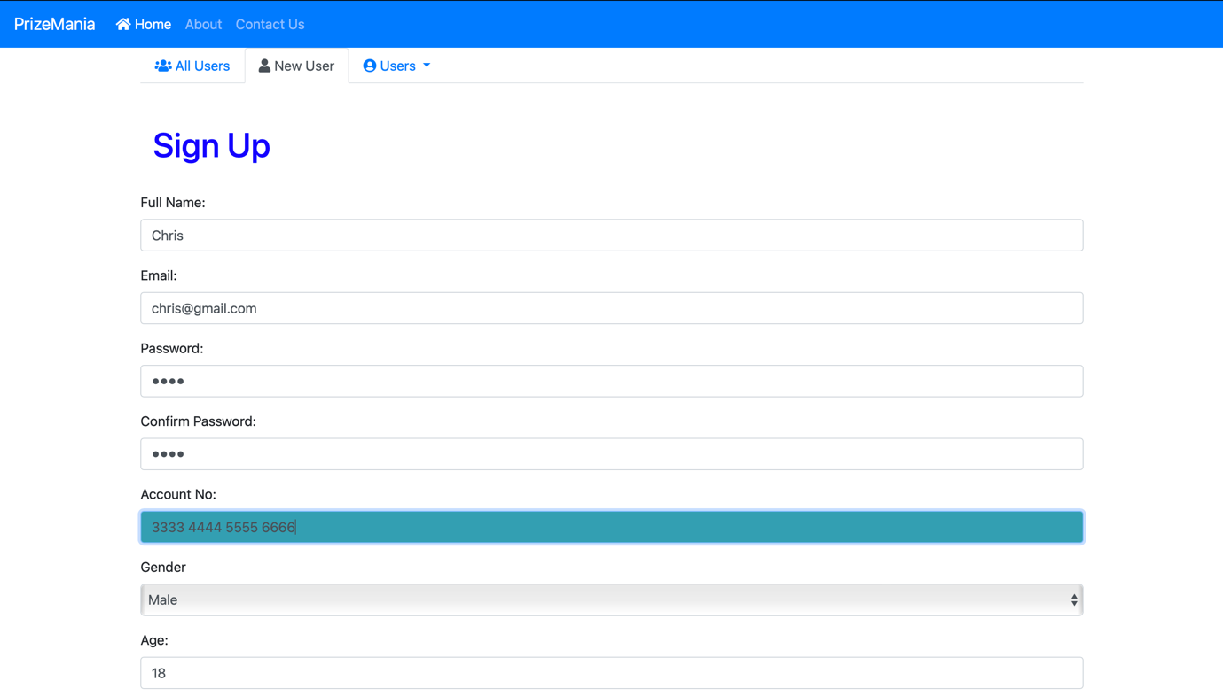

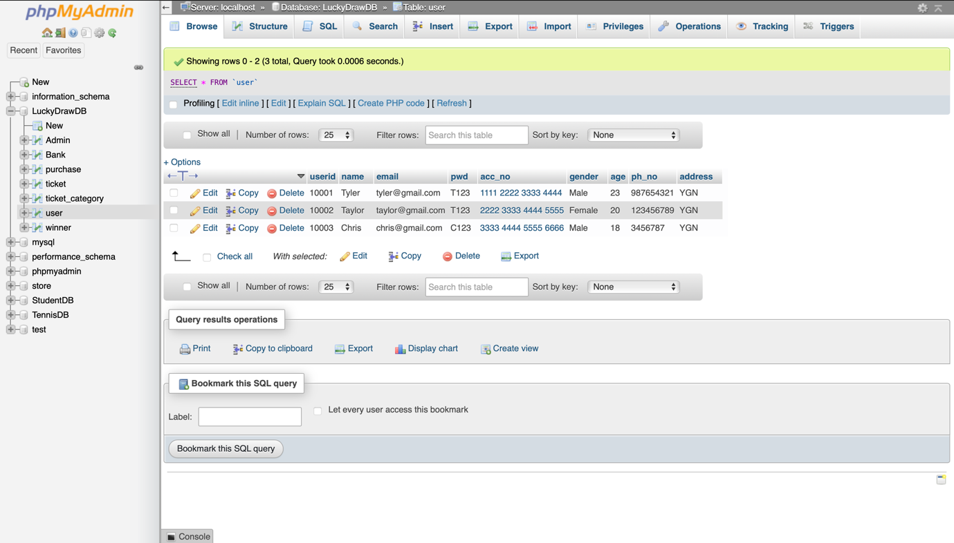

The data added has been recorded in the user table.

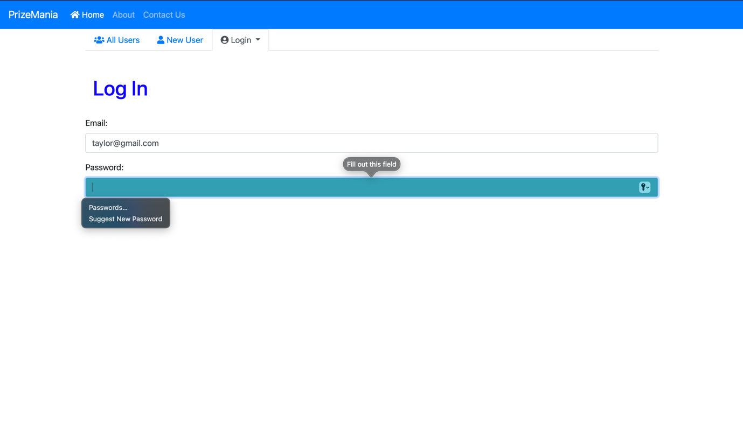

If we do not fill all the require fields, it will show like this again.

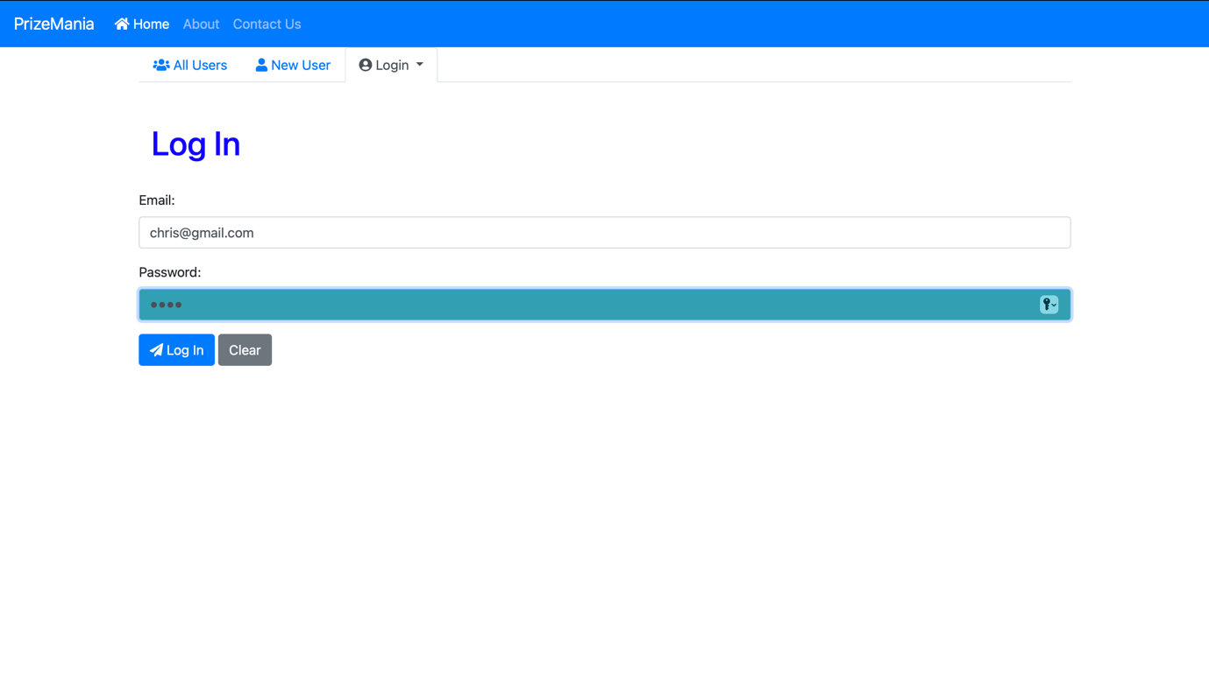

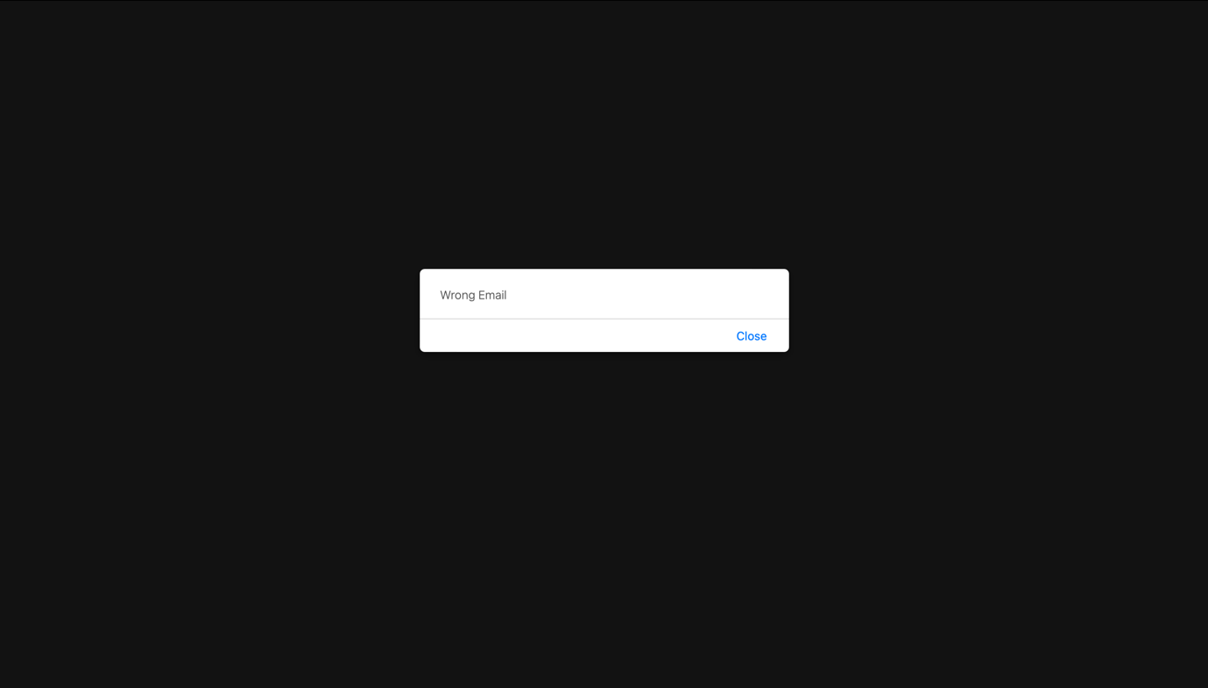

If we write wrong email address, it will show “Wrong Email” in both user login and admin login. When we write the correct email and password, it will lead to the purchase page to buy tickets.

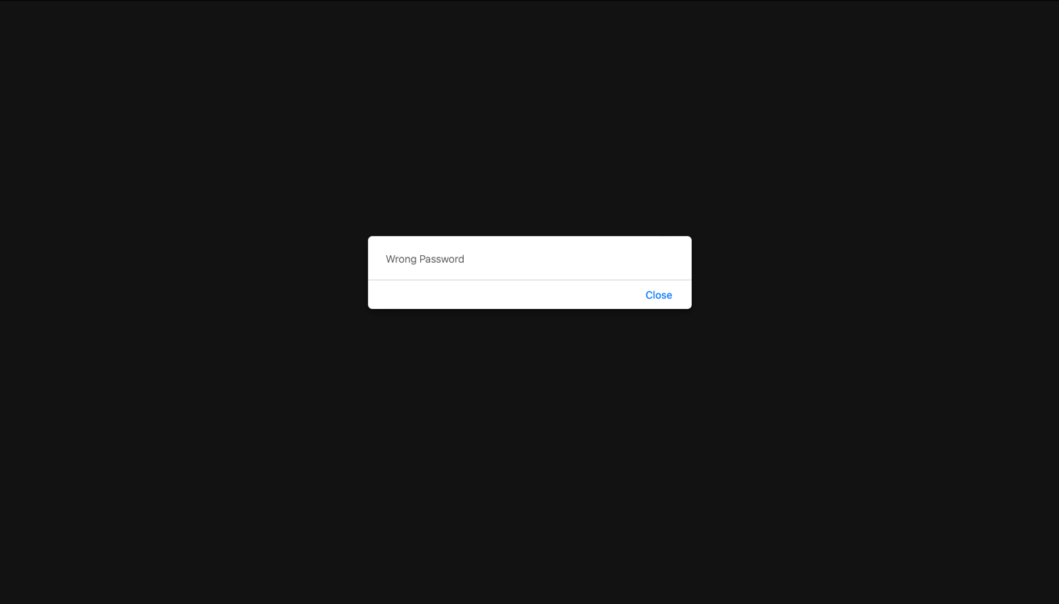

If we write correct email address but wrong password, it will show “Wrong Password” in both user login and admin login.

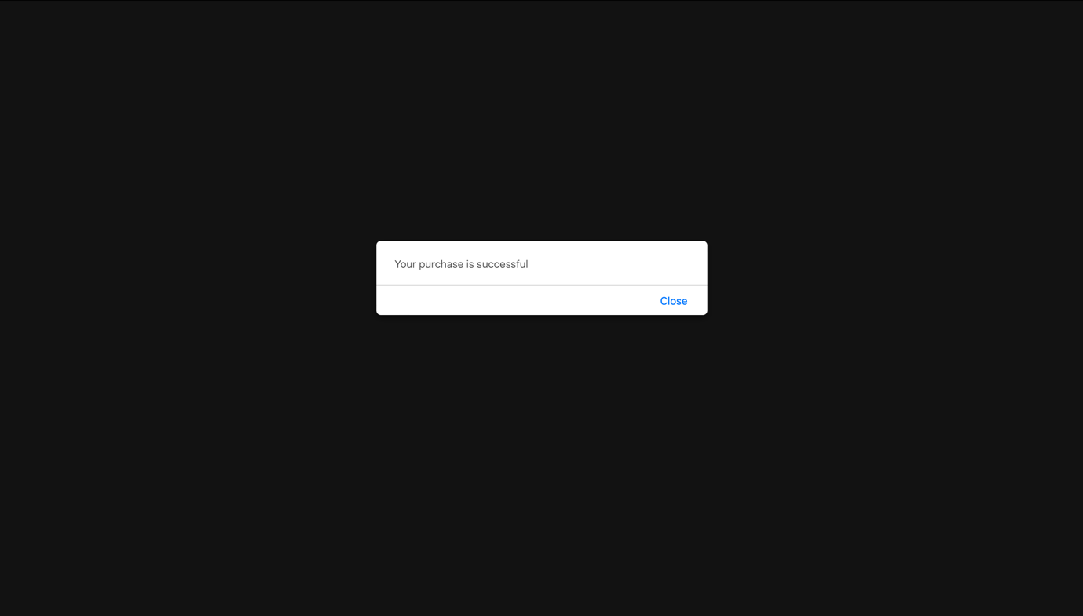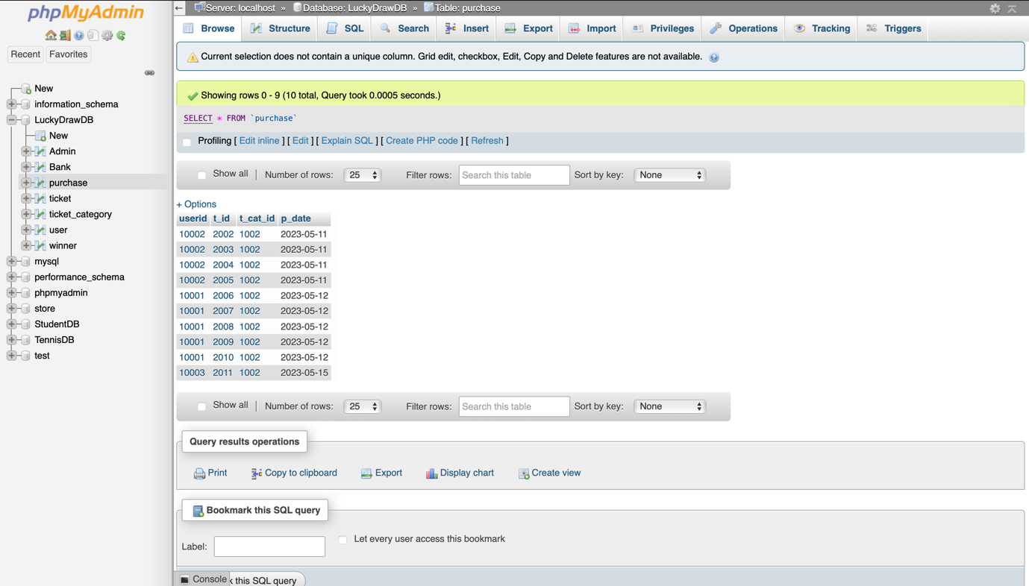

You will see one data is added to the purchase database.

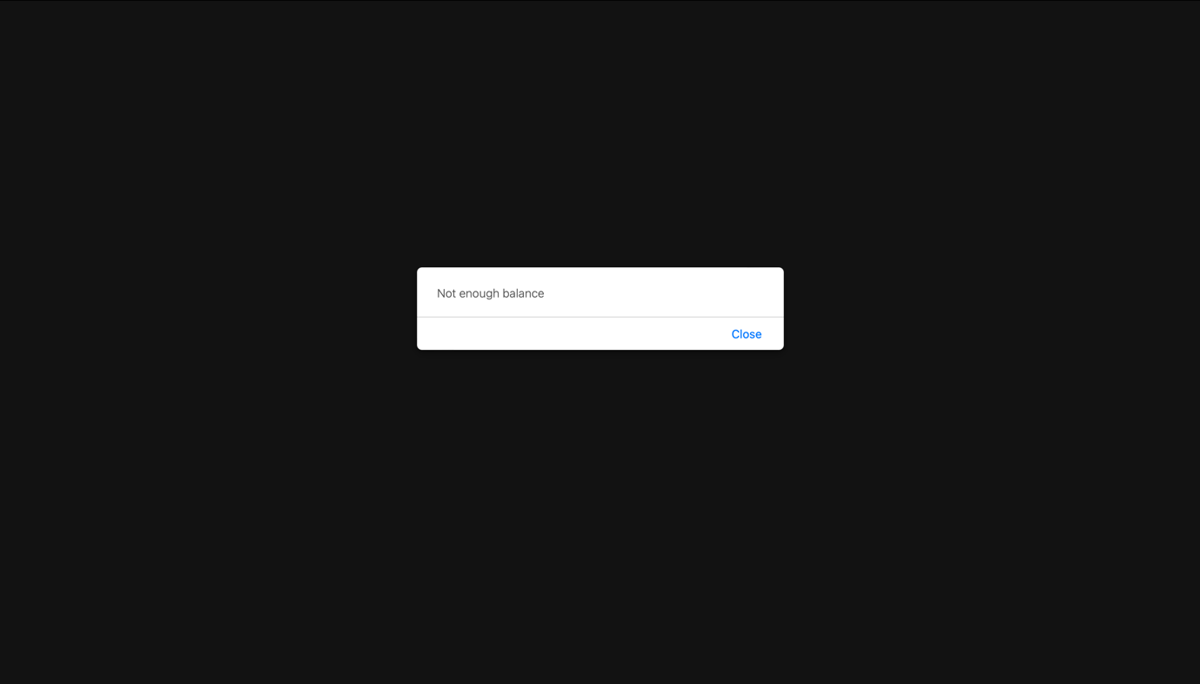

If we buy tickets but not enough money in the bank account, it will show “Not Enough Balance”.

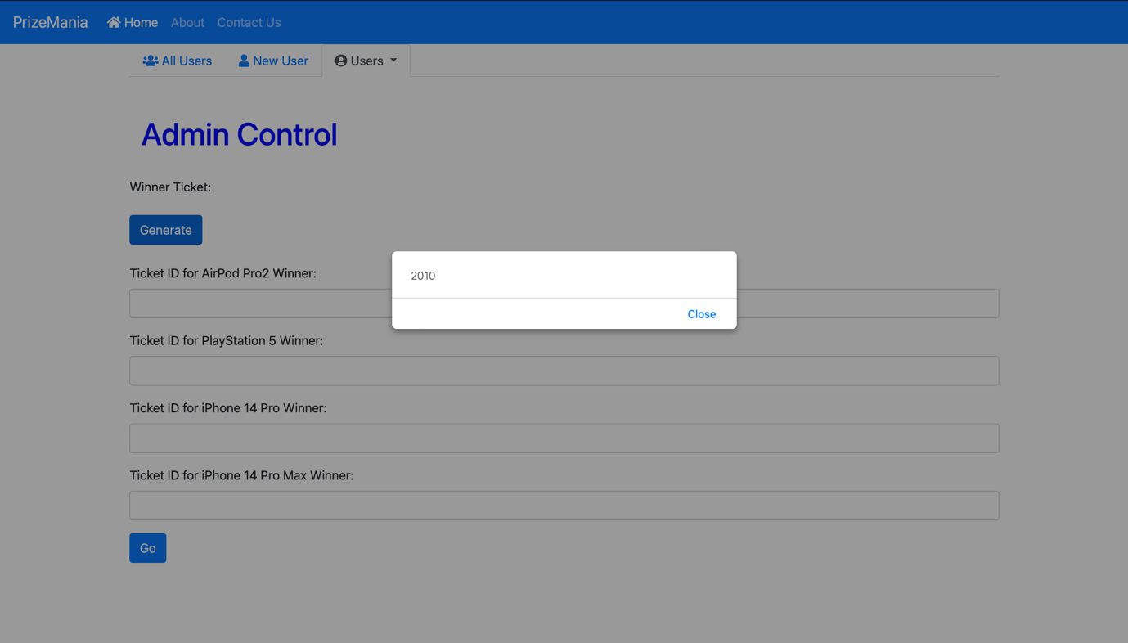

In admin control page, clicking generate button will randomly show ticket IDs for the winners.

## **Changeover Procedure (System Implementation Plan)**

How we developed the software

1. Requirement Analysis - Each software and hardware need that is going to be used in the process of developing software should be defined and analyzed.
2. Design Implementation - The process of determining how an information system ought to be developed (physical system design), confirming whether the information system is functional and being utilized, and making sure the information system complies with quality standards is known as systems implementation, also known as quality assurance.
3. Software Development - The software engineers start coding and building the system using all the reliable source code and the right technique.
4. System Testing - Following system development, the program is evaluated to verify if it is prepared for public release.

## **User Manuals**

Home Page

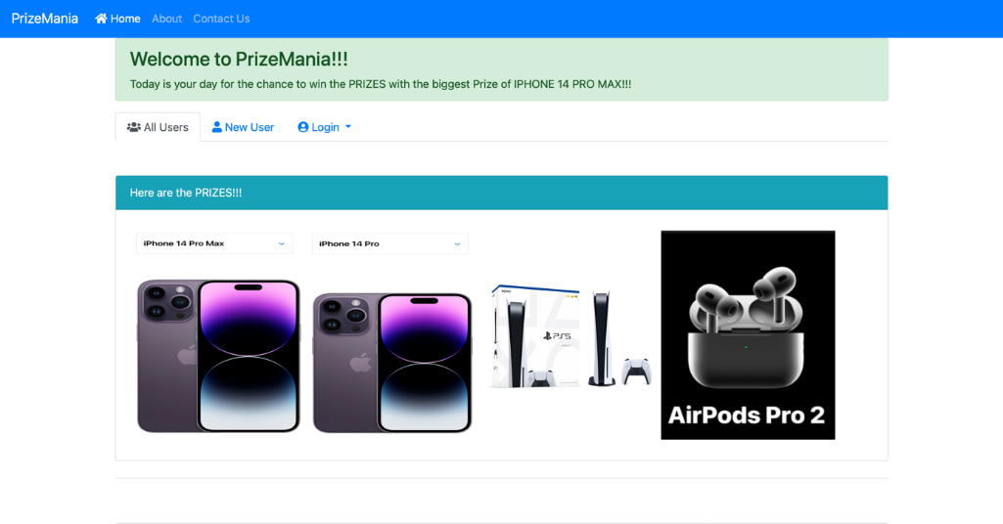

This is the home page that comprise all user, new user and login pages

This is the login for the old user and for the admin

This is the Sign-up for the new user

About Page

This is the information of the website

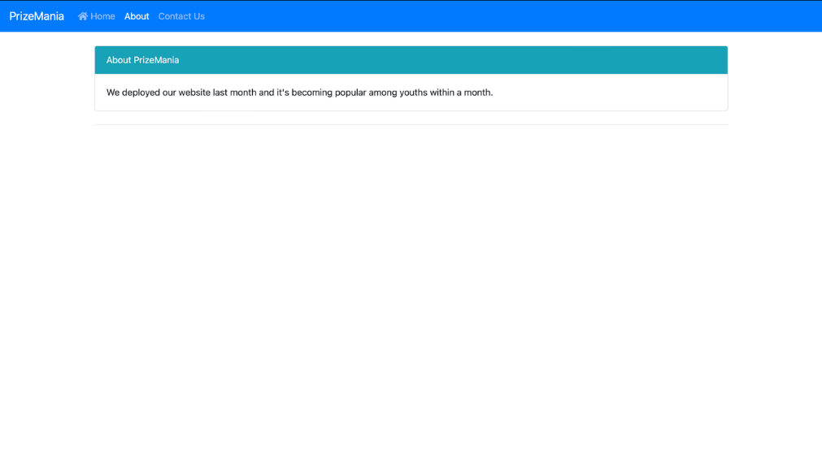

Contact Page

This is the contact number of the authorizer for more about of this site.

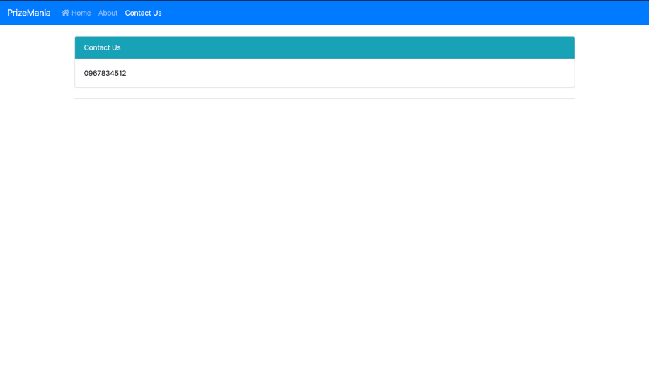

Signup Page



If the user is fully filled the text field and click on sign up button the data will upload in the database

This is to clear all the text field.

User Login

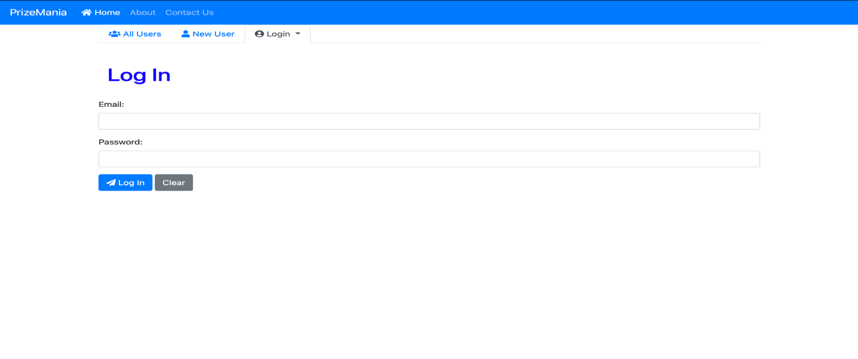

This is to clear all the text field.

If the email and password are correct the user are allowed to get into the system

Amin Login

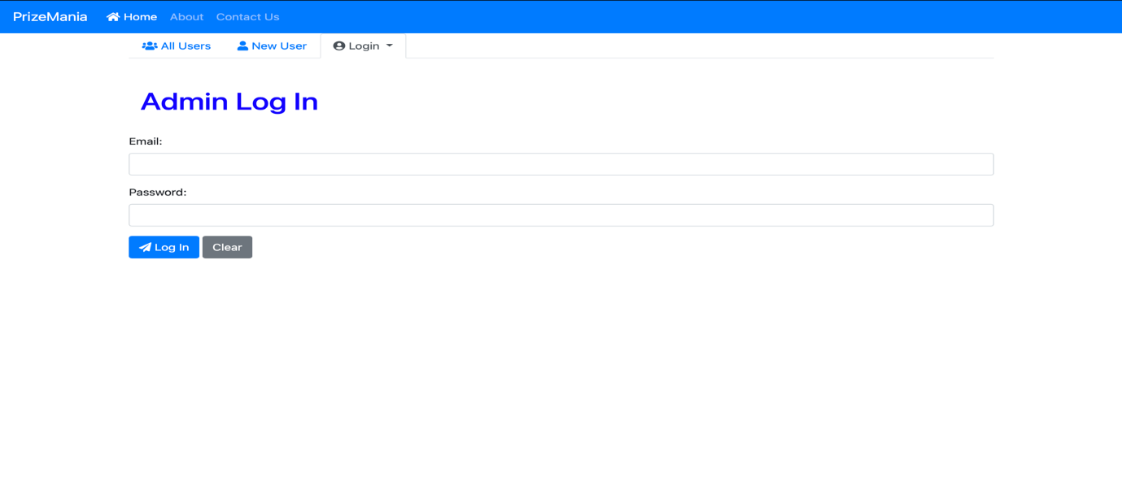

This is to clear all the text field.

If the email and password are correct the Admins are allowed to get into the system

Purchase Ticket Page



This is the log out button to logout from the system.

If users choose the quantity and click on the buy button the purchase data will upload in the database

Admin Control Page

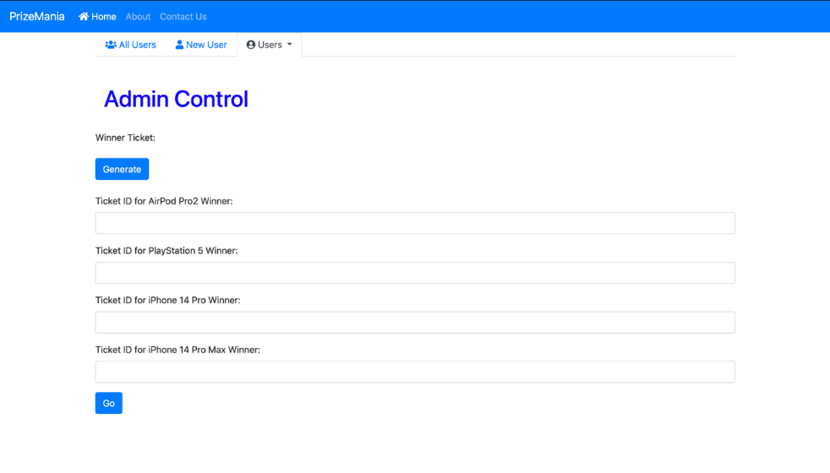

If admin click on generate button the data will appear in the Ticket id field.

# **Section E: Critical Appraisal**

## **﻿System Limitations**

Users cannot view the tickets that the already bought.

## **Recommended Changes**

In this system, user can view the ticket. So, I just want to change the system that a user can’t view the ticket that already bought.

## **Critical Reflection of the project experience**

A lucky draw system's design and development are not always simple. It requires a significant lot of risk and difficulty for me. I had to do extensive study on MySQL XAMPP, and Visual Studio code. The plan, the scope, the budget, and the drawings, among other documents, must all be put together. I encountered several challenges while working on this project. For example, I didn't have enough time to integrate the features I intended to, so I had to start again and rebuild all the code and designs. One of the benefits was that I gained a ton of amazing skills and knowledge about management practices. I believe that because this project required me to work alone and rely only on myself, it considerably boosted my strength and self-confidence. I will surely take new challenges for new initiatives, even if they are difficult, and work to hone my management and development abilities.